Visual Design for Greenfield Local Hub

Site map:
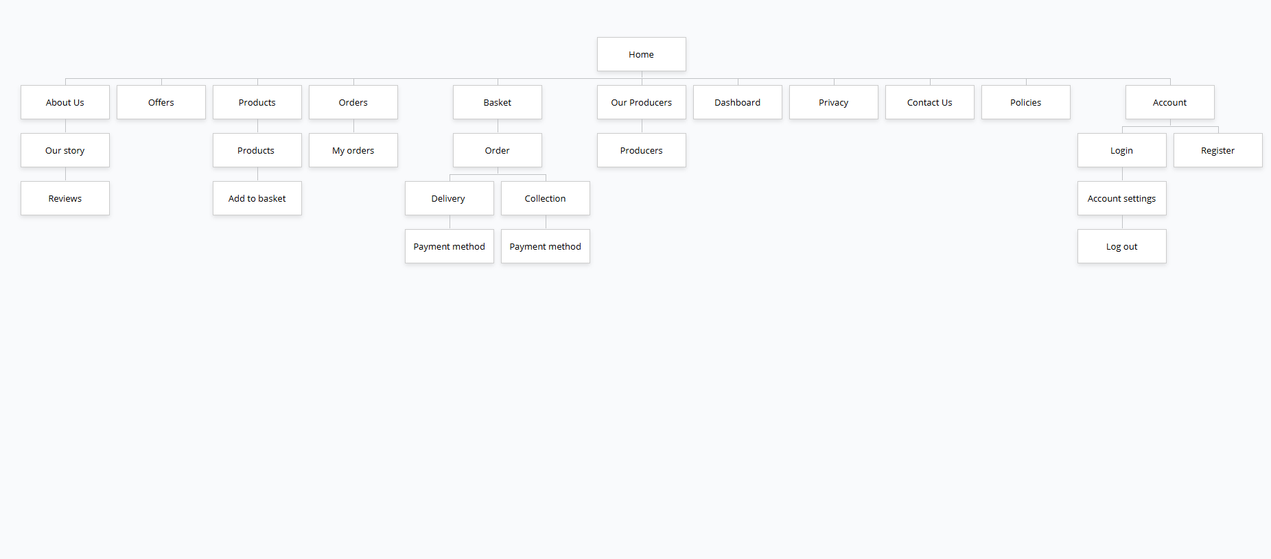
Home – The landing page for potential customers. It contains specified sections that tells the users what the website is about and where to go.
About us – It shows information for anyone who wants to learn more about the company.
Offers – It contains potential special offers and discounts for loyal customers.
Products – It contains products that are can be ordered through the website which are sold by multiple producers. Products can be filtered by the user’s preference. Through that, users are able to add products to their “basket”.
Orders – A transaction that is stored once a customer has ordered a product. So, the customer can see their past orders.
Basket – It allows potential customers to store selected products before ordering. It tracks the quantity of the products and calculates the total costs.
Delivery – It is an efficient way of delivering the product to the customer directly to their homes by using the post code provided.
Collection – It helps customers find what they are looking for quickly and easily. Allows the customer to collect the product themselves.
Payment method – It allows customers to pay for a product using their digital wallets, credit cards and debit cards.
Our Producers – It shows all producers that are selling the products on Greenfield Local Hub.
Dashboard – A page that strictly allows users with the role “Producer”. It displays all producers, pending orders with the products.
Privacy – Outlines how personal data is protected, how data is collected and how data is used.
Contact Us – Allows visitors or potential customers to contact the business.
Policies – Provides information about legality on the website to keep the business safe and the customers safe.
Account- Contains the user’s account on the website.
Login – Allows a user to login.
Register – Allows a user to register.
Account settings – Allows the user to manage their own personal account.
Log out – Allows a user to out.

